SAMPLE CHARTS AND MAPS

The following are samples of charts and maps we can show

1. A Pyramid population chart

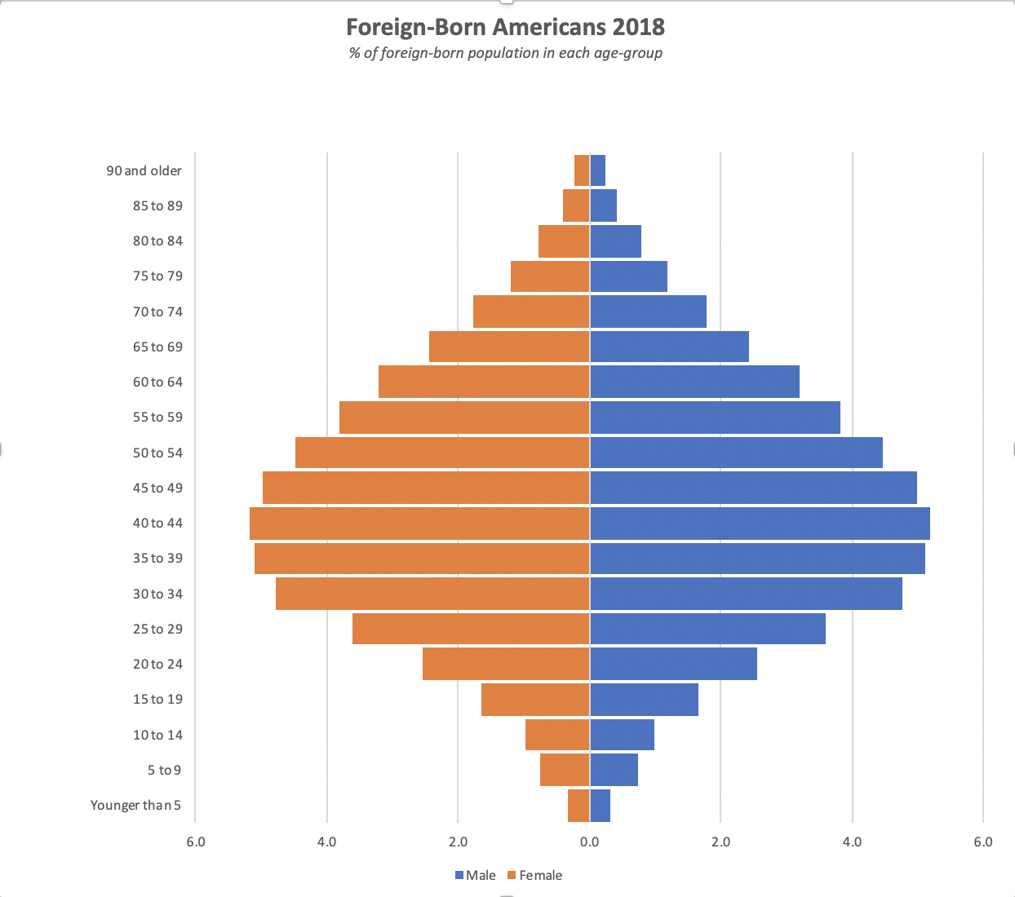

1. Stacked bar charts for selected demographics

Two stacked bar graphs are presented below for education attainment of immigrants: T

1. The first one uses percentages – the gaps between the bars were removed. If gaps are maintained, the graph would be similar two the second one.
2. The second graph is also a stacked bar chart. However, this one includes the actual number immigrants in each education group instead of the percentages.

**Suggestion: A dropdown menu that allows the user to select a region to display the education profile of the region would be interesting.**

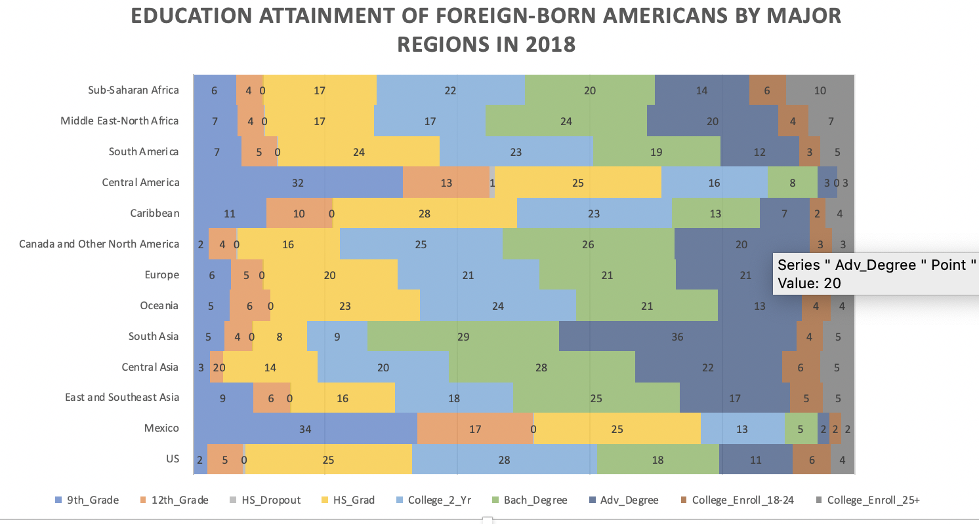

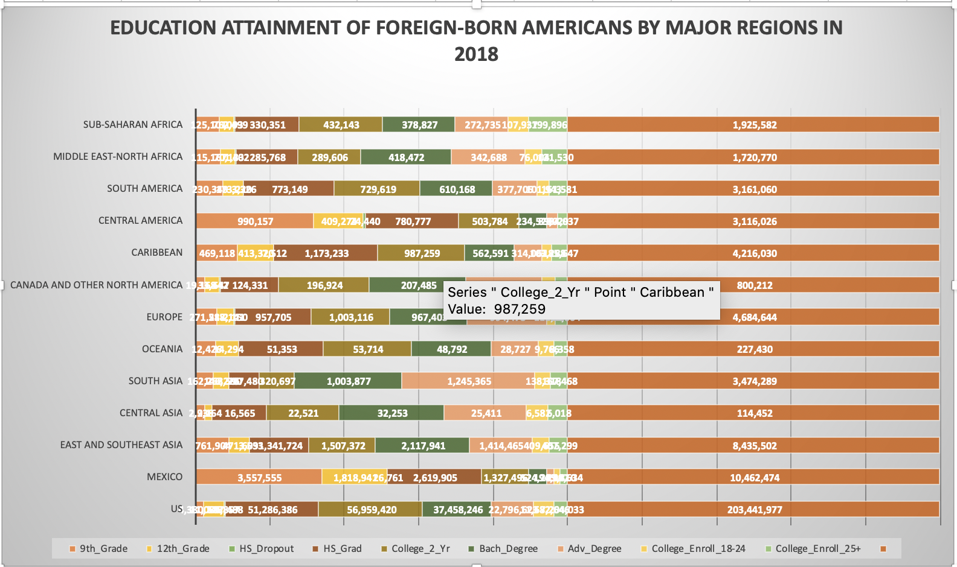

1. The following charts can be used to display income profiles

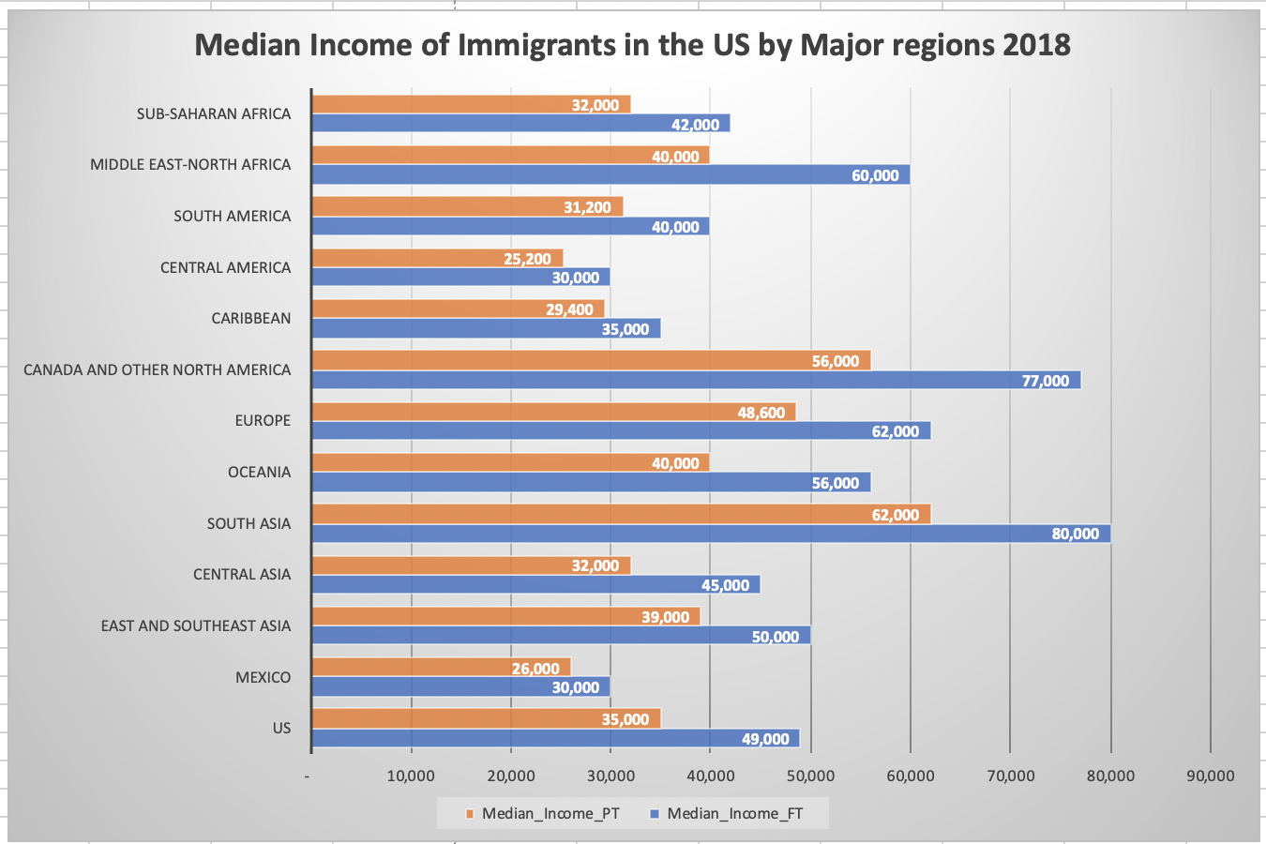

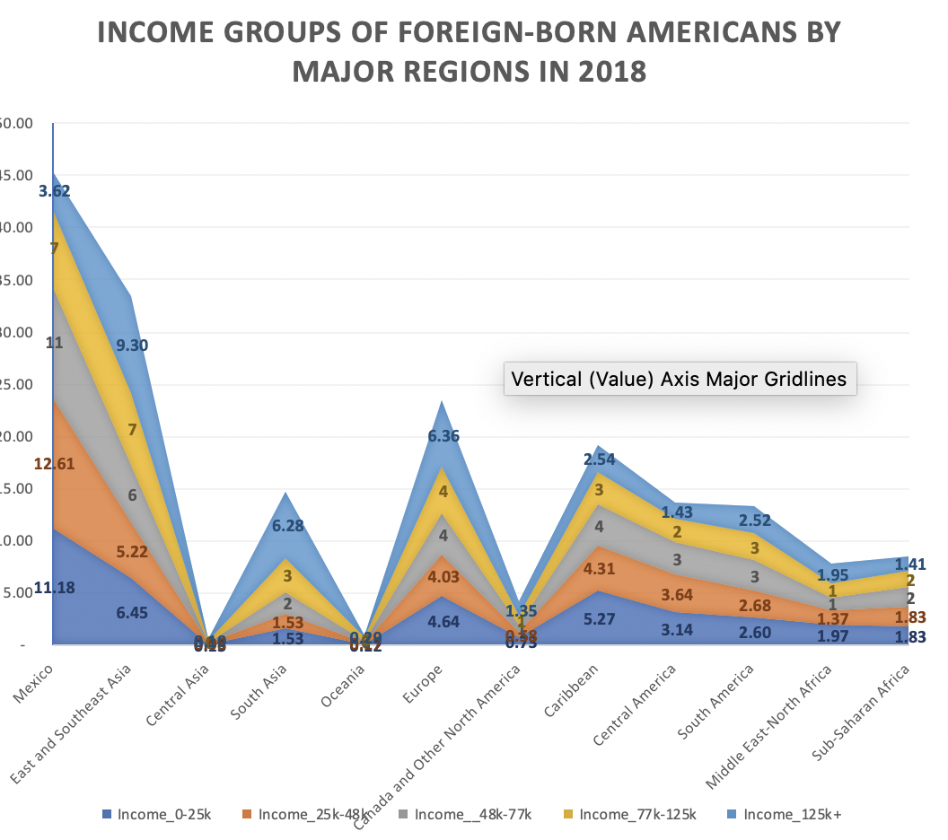

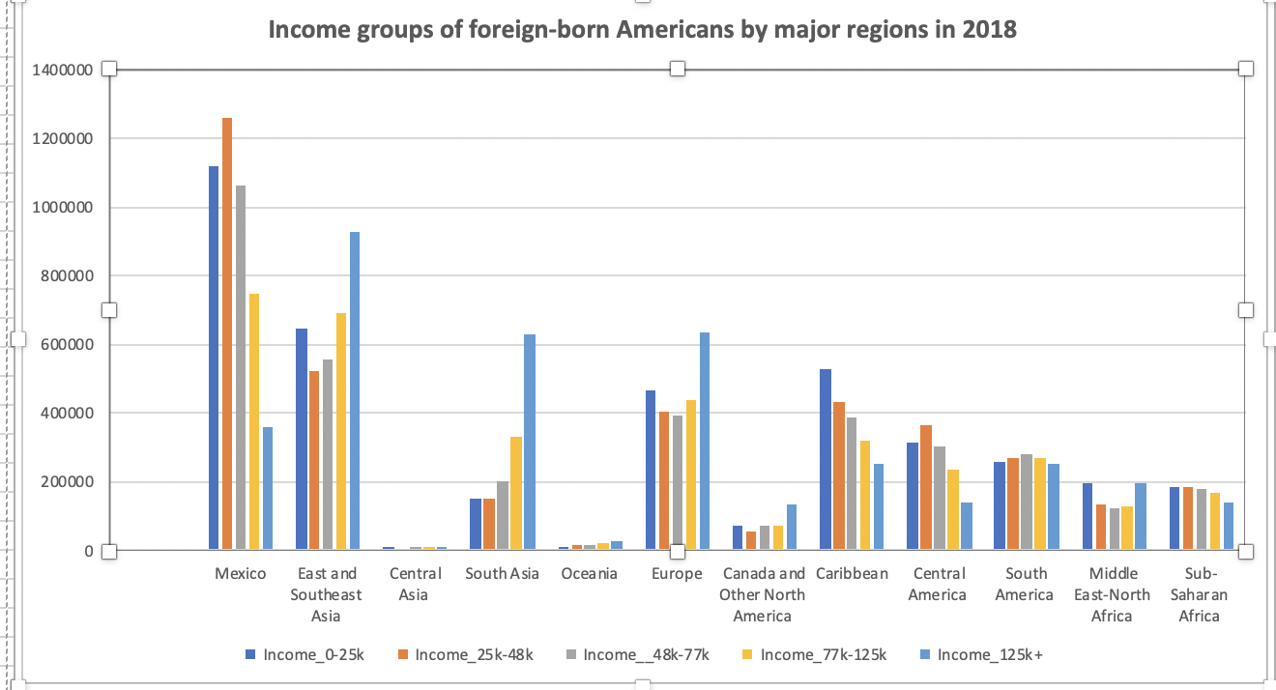

1. The following are different ways workforce profile can be displayed
2. Chart one is a stacked line chart
3. Chart two is a traditional line graph.
4. Chart 3 is a part chart using Mexico as a regional selection example.

**Suggestion: If we want to display this particular demography, I think a dropdown menu may be a better approach to do it. In the dropdown will be the major regions. Of a user selects a region, the workforce profile of immigrants in that region will be displayed in a pie chart for example.**

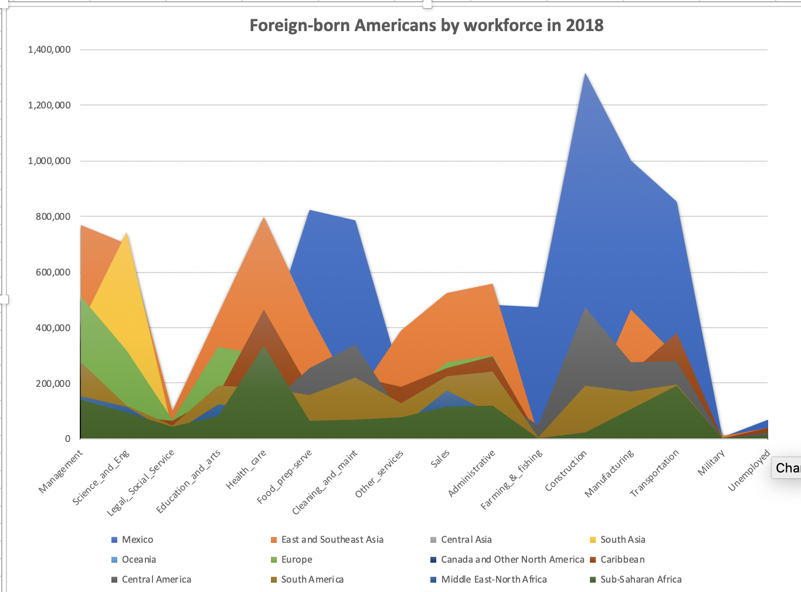

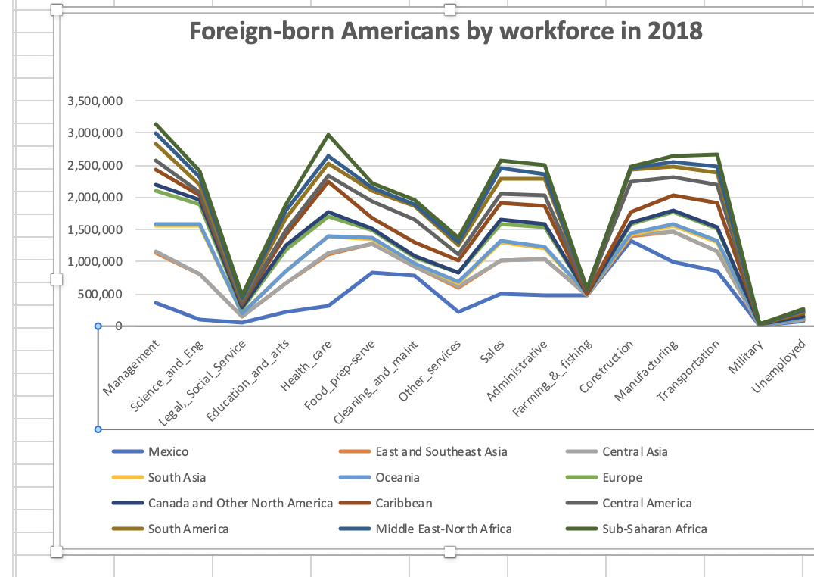

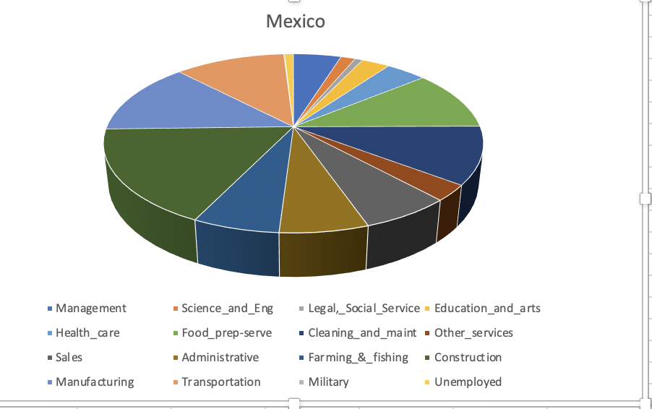

1. A heat map with bubbles and a hover

An interactive map that shows the states (and counties) of residence for immigrants in the United States based on their country or region of origin.

1. Select a country or region from the dropdown menu to learn where immigrants from that geography settle in the US.
2. Display state immigrant concentrations with bubble and a hover that a hover over a state to get state immigrant population and few selected demographics. The size of a bubble will be determined by immigrant population in the state.

The map below from the Migration Policy Institute can be a template for us.

